**Objective & Scope of work**

**SCOPE OF WORK:**

**Public Pages:**

1. Home
2. About
3. Courses
   1. Course details
      1. Subscription plans
4. Contact
5. Terms and conditions
6. Privacy Policy

**Roles**

1. Admin
2. Student
   1. School Student
   2. General Student
3. School Admin

**For Admin Role:**

**A) User account:**

1. Login screen. Login with Email/Username & Password.
2. Forgot Password. A new password will be sent by email.
3. Admin can update the profile.
4. After logging-in admin can create/set/update any of the following:

**B) Course**

1. Admin will be able to add/edit the course
2. There will be fields like –
   1. Title
   2. Author
   3. Description
   4. Price type (subscription, fixed, both)
   5. Category
   6. Scratch code CSV import - List of scratch codes for a single book which was published for students. This List only can be imported from CSV.
   7. Show/hide on listing page
   8. Visibility (public / only for members)
   9. Video of chapters
   10. Audio of alphabets
   11. Practice section (Individual alphabet/chapter or set of alphabets/chapters)
   12. Activities from the library of already created activities (Individual alphabet/chapter or set of alphabets/chapters)

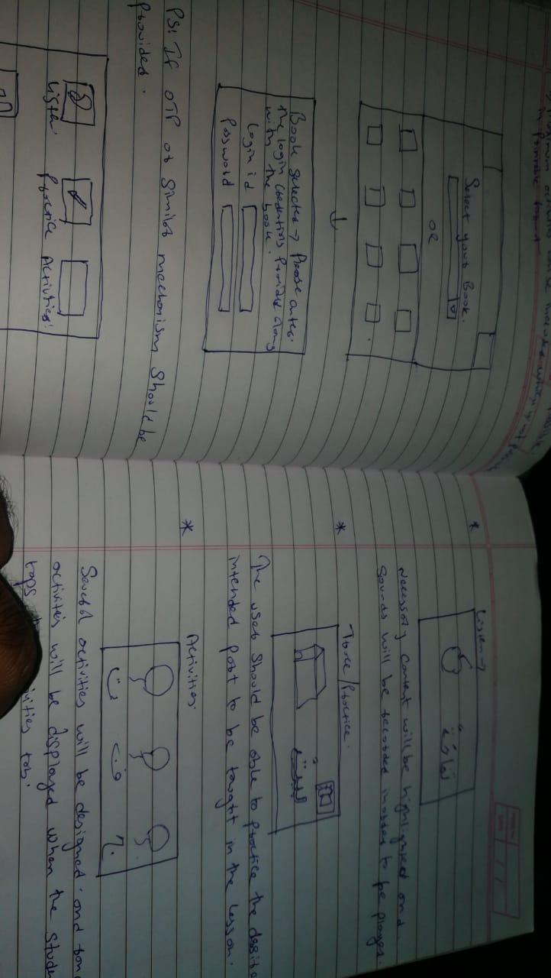

**Activities:-**

1. Join the dots & colour
2. Match the column (interactive)
3. Fill in the blanks
4. True or False
5. MCQ

Note: Each video chapter will contain single or multiple types of activities.

3. There will be an automatic scoreboard based on the activities undertaken which will be available for school admin to see.

4. There will be history of the number of attempts for activity, the result of the last attempt will be stored in the database.

5. Standard wise books, other categories like learn language, related to academic

**C) Subscription**

1. Admin can create subscription levels with Name, details, price, etc.,

2. For example, admin creates subscription levels as below:

a. Basic Plan: per month with accessible of “ 3 books” / “single category containing list of all books”

b. Advanced Plan: per month with accessible of 5 books / “single category containing list of all books”

3. Admin can edit/delete the subscription plans  
Subscription plans will be based on categories e.g. Arabic language category will have its 3-4 plans, history category will have its 3-4 plans, Islamic Studies will have its 3-4 plans etc.

**D) Scratch code**

1. Physical copies of the book may have a unique code. The copies which get sold in schools mainly will be having code.

2. Once the student logs-in to account and enter the unique code, the particular course will be available online.

3. The scratch code will be valid for one year from the date of online submission. After that the book won’t be visible to the user.

4. Each scratch will automatically fill details of school, e.g. when we enter Pincode the city automatically is set.

5. Subscribe and retail books will not have a scratch code

**E) Reports & Misc**

1. User database

2. Sales report per month

3. Admin can create other users or sub-admins

4. Admin can update email or change password

**For Students Role:**

**F) User account:**

1. Registration:

a. School student will register with the unique code provided with the book using with OTP that will be sent on their mobile numbers

b. General student will signup normally and subscribe to a course

2. Login screen for students.

3. Forgot Password. A new password will be sent by email.

4. Student can edit profile. At the time of edit profile student can select school from the list.

5. After logging-in the student will reach the dashboard from where he/she can access the following:

**G) Access courses**

1. Students will have access to their respective courses

2. They can read, watch, take up activity, check their score etc

3. If the access is limited by time, like one year or one month, it will be locked after the period

4. Books, videos will be available in the website environment only.

5. Repetitive activities, keep track of activity attempts

6. Section wise - activity report, share with teacher

**H) Subscription**

1. Students can subscribe to any plan/course of their choice

2. Once subscribed to the plan then selected books will be accessible for the student in the account.

3. There will be no auto-renewal for the subscription. Students can renew the subscription plan manually with payment for next month/year.

4. Students can upgrade or downgrade the subscription plans.

5. Payment gateway Razorpay.

**For School Admin Role:**

**I) User account:**

1. Registration: Admin will create a school admin account.

2. Login screen for school admin.

3. Forgot Password. A new password will be sent by email.

4. School admin can edit profile

5. After logging-in the school admin will reach the dashboard from where he/she can access the following:

6. School students list with activities scoreboard report

Teacher login will also be there

Teacher can view class student and their scorecard.